Software requirements specification

Contact info:

Group Number 3, including:
Ilan Kroter,Stav Lobel,Ivan Rubinson,Alon Gabay ,Ilan Tolpov,Lidor Zaguri,Itay Klaf,Ron Shokoury.
Email: IlanKroter@gmail.com
Phone: 053-2248-710

The purpose of this document is to give a description of a system to handle technical issue, that is meant to support company workers. It will illustrate how the interfaces work, the various purposes and advantages of using this system. Also contains a brief overview of how it would work.
Who will use the app:
Company workers and the service givers of the company (see: definitions).

Definitions:

The system would work with the following kinds of users:
- The customer- A worker in the company whom faced a technical problem in the companies' apps or any standard computer problems.
- Helpdesk – The first level for facing a problem. The helpdesk team tries to handle the problem first on their level, trying simple tasks or known repairs on their field (those that don't require the person to arrive at the spot or do lengthy repairs). They also should handle the service calls that the customer opened.
- Technicians- They handle all the cases the helpdesk can't handle due to experience, the need to arrive at the worker's place, or due to time management.
- Engineers - When a problem is more severe and needs a review of the system the problem is present on, they should be the ones that can solve the problem most of the time.
- Technical leader - The person in charge of a team of support givers.

Ticket types / supported systems: anything that is technical

Support Tiers:

There are several levels of treatments to a service call (see definition) that go by the skill that every type of support giver has.
The standard tiers in this software are of the following order:
Helpdesk, technicians, engineers. While the technical leader is part of each team and is in charge of more complicated matters on each level.

Service Givers -
Members of the workers that handle problems in the system include: helpdesk, technicians, and engineers.
Service Call -
A service call (or ticket) is a problem definition, that is used for sorting the problems into a more organized form to handle them better, including the person or team in charge of handling the problem, and all additional data that can help solving the problem.
User -
The user is a worker in the company.
Management view -
The mode of the system that allows service call handling, it's meant for workers of the company that handle problems.

Background:

In many organizations which have a technical support department, there needs to be a management and control system that could handle the vast information of many technical problems they are in charge of, this system is rooted on the company workers and their ability to use this kind of information to solve their problems in the best possible way.

Why?
When a company grows, the volume of issues increases. The existing mechanisms wear down, and if there's no order in the documentation and solutions, there can be chaos. In addition when there are a lot of unresolved problems, new problems may rise additionally.
When the volume of information is high, human error may occur, and issues may mistakenly go unresolved, or the service quality is lowered.

Solution:
Software system for the management of technical support tickets, which will serve the users, and optimize the existing mechanisms.
In addition, the system offers high-level overview dashboards, which manual systems do not.

System overview:
The life cycle of a service call:

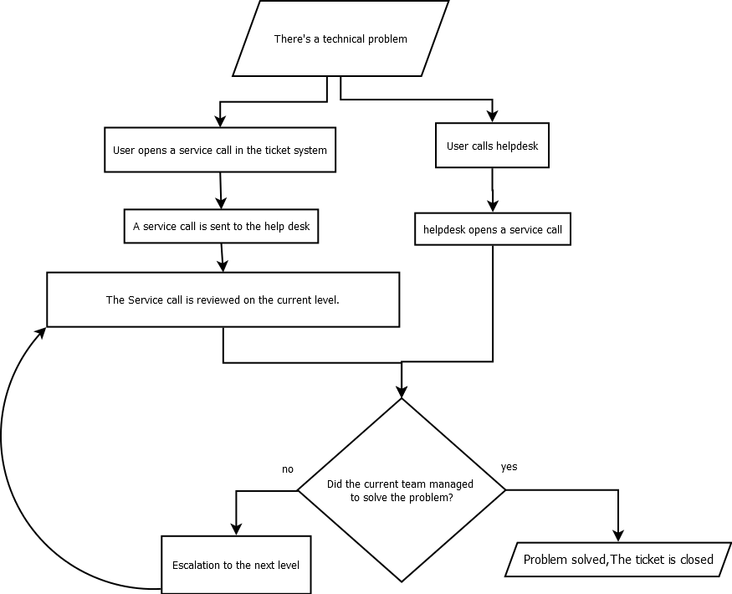

Overview:
The process of problem solving using this system, starts with the user facing a problem. He decides to address either the systems self service, or call the helpdesk; in both cases the service givers try to help the user, and if they manage to help they close the service call at the helpdesk level. If not the ticket is escalated to the next level or the technical leader of the team, and they try to handle it. The problem may be escalated further until the problem is solved.

Overall description

Product functions:
- Create tickets
- Read tickets
- Update tickets
- View, sort, filter all tickets
Supporting functions:
- Log-in & authentication
Allows joining tickets to particular customers (see definition of customer)
and accessing management functionalities for support givers

Constraints
- Program will be run on a single machine
- Memory & other hardware limits of said machine
Assumptions:
- Support givers are able to access & operate the computer
- Users are able to access & operate said computer, or contact someone who can (e.g. phone call to support giver)
- Data integrity & back-ups are not managed by this system

Functional requirements

User class – The customer:
Customer – see definition of customer.
Customer can create new tickets, providing basic information like
- Type
- Title
- Detailed description
Customer can also view (read-only) the tickets that they opened.

User class – The support giver
Support giver – see definition of support giver.
Support giver can create new tickets, providing initial information like:
- Type
- Severity
- Title
- Description
Support giver can edit existing tickets:
- Add notes
- Change status (like close the ticket)
- Escalate
- Change stakeholders
Support giver can list tickets by various filtering criteria

User class – The technical leader
Technical leader – see definition of technical leader
Can do everything a service giver of the same tier can.
The listing and filtering of tickets in particular is a tool that provides the leader with insight in to the effectiveness of their support givers, and the general health of the supported systems.
See definition: supported systems

